**MONGODB TASK2**

1. Find all the topics and tasks which are thought in the month of October

**Query:**

1. **db.task.aggregate([{$match:{date:{$gte: ISODate("2020-10-01"),$lt: ISODate("2020-11-01")}}},{$project: {topic: 1,date: 1}}])**

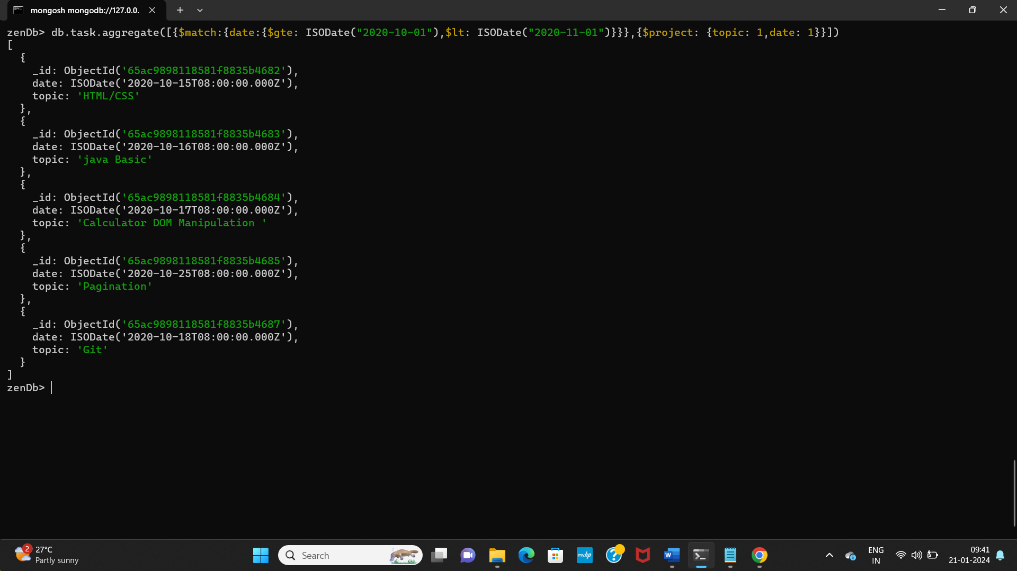

1. **db.topics.aggregate([{$match:{date:{$gte: ISODate("2020-10-01"),$lt: ISODate("2020-11-01")}}},{$project: {topic: 1,mentor: 1}}])**

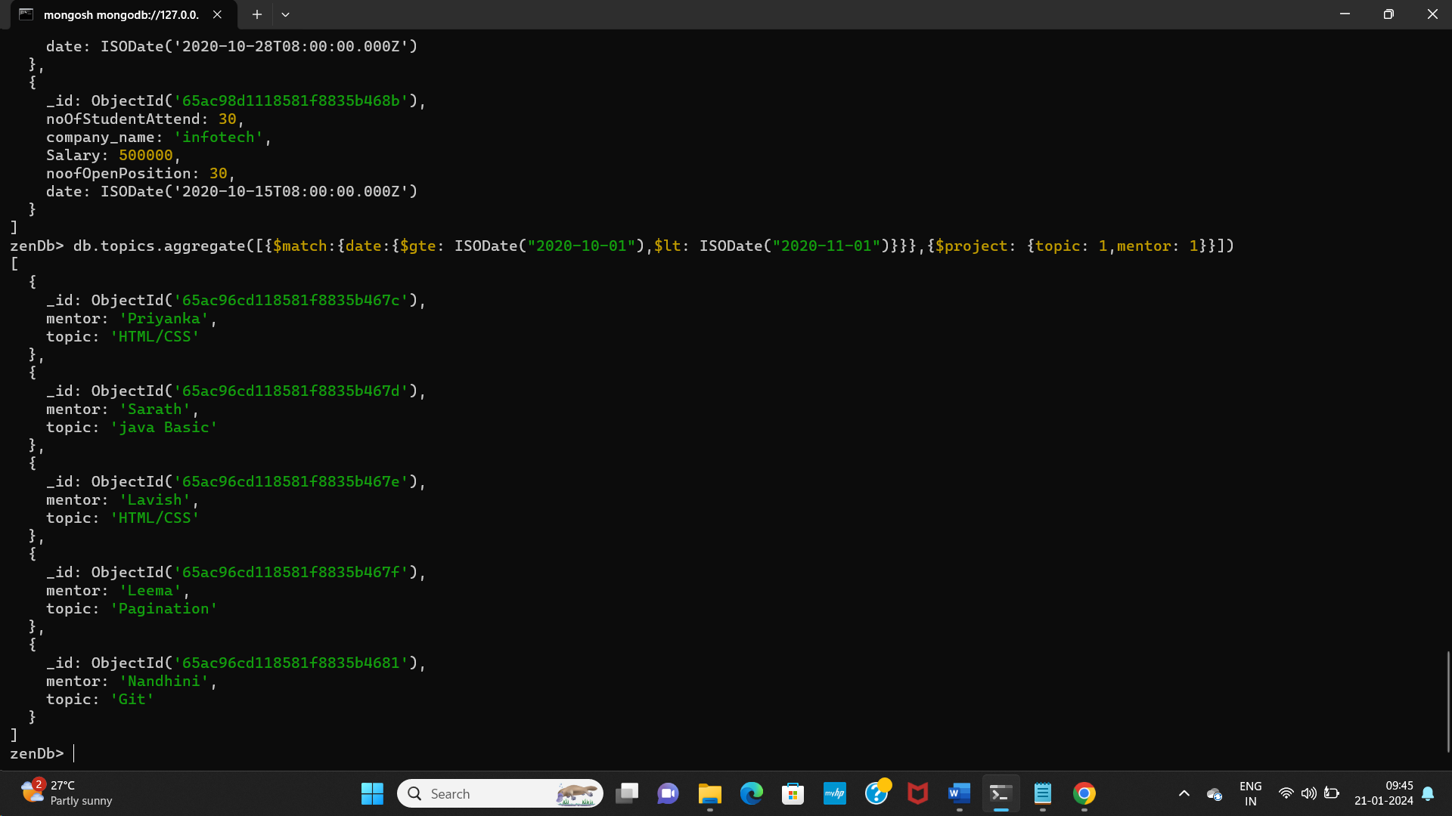

1. Find all the company drives which appeared between 15 oct-2020 and 31-oct-2020

**Query:**

**db.Company_drives.aggregate([{$match:{date:{$gte: ISODate("2020-10-15"),$lte: ISODate("2020-10-31")}}}])**

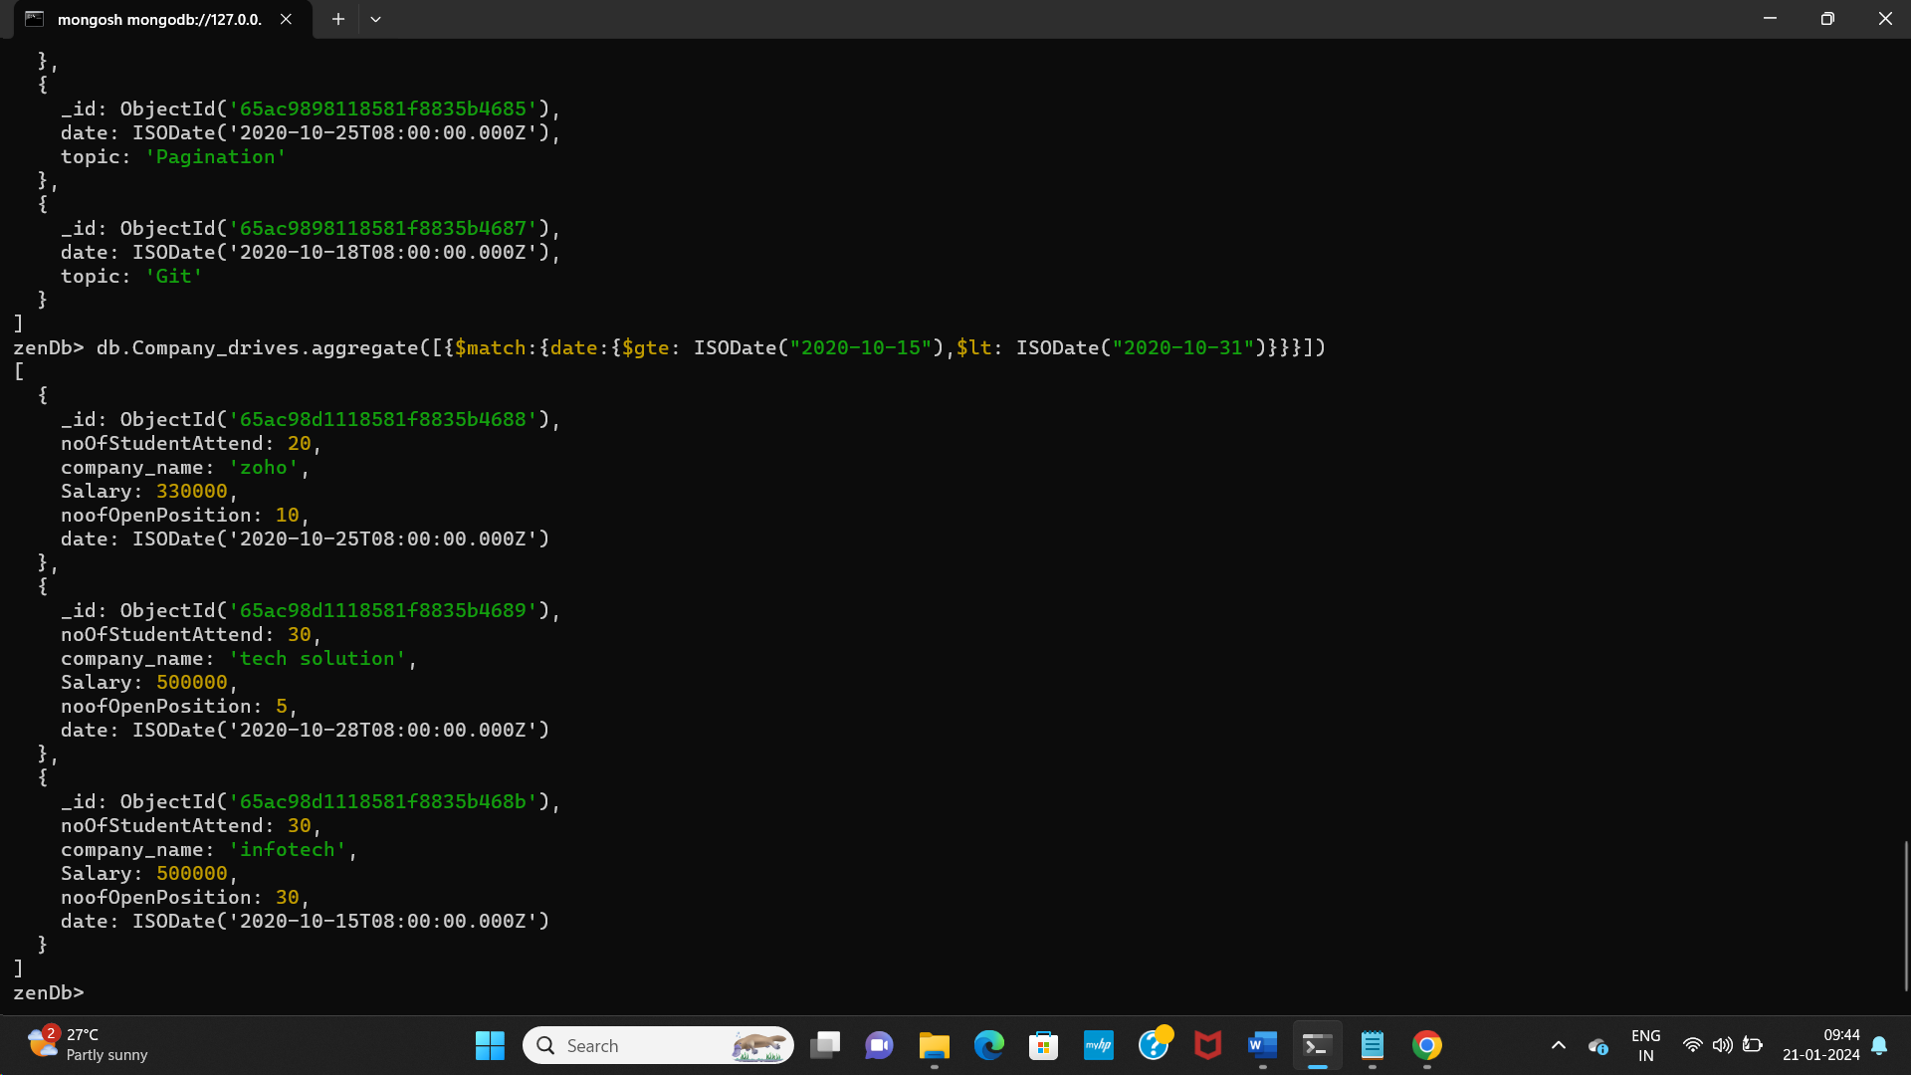

1. Find all the company drives and students who are appeared for the placement.

**Query :**

**db.Company_drives.aggregate([{$lookup:{from:"user",localField:"company_name",foreignField:"company_attended",as:"CompanyDetails"}}])**

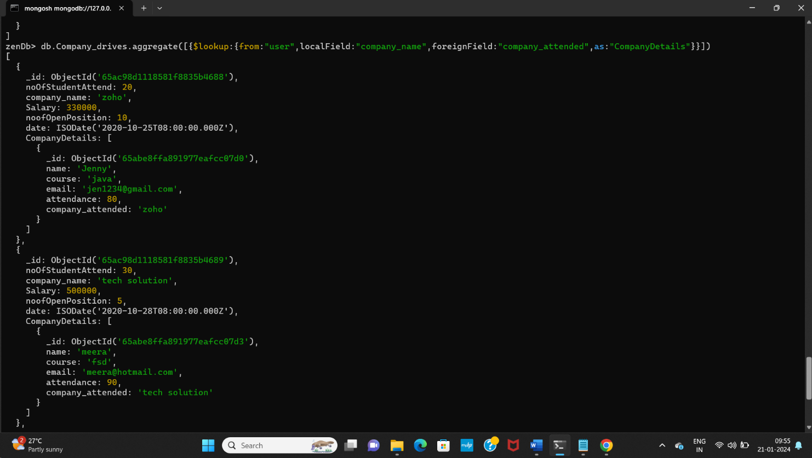

1. Find the number of problems solved by the user in codekata

**Query:**

**db.codekata.find({},{name:1, problem_solved:1})**

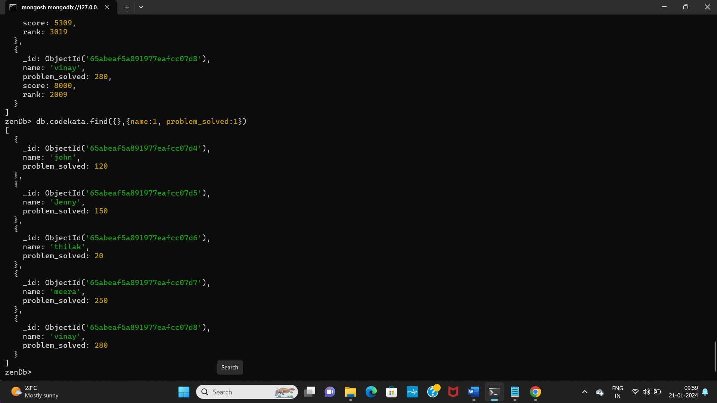

1. Find all the mentors with who has the mentee's count more than 15

**Query :**

**db.mentor.find({noOfMentees:{$gt:15}})**

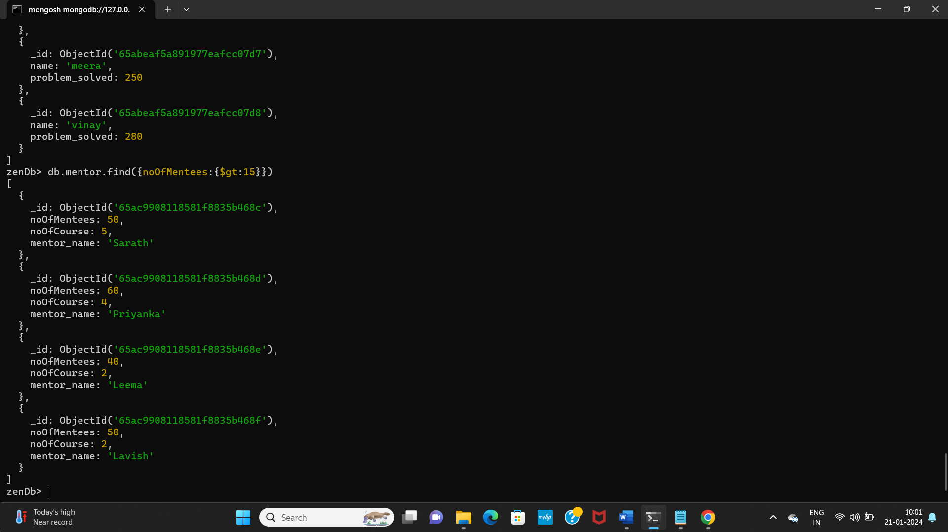

1. Find the number of users who are absent and task is not submitted  between 15 oct-2020 and 31-oct-2020

**Query :**

**db.getCollection('Attendance').aggregate([{$lookup: {from:'task',localField: 'topic',foreignField: 'name',as: 'taskInfo'}},{$match: {$or:[{ 'taskInfo.submitted': false },{ 'taskInfo.date': { $lt: new Date('2020-10-15') } },{ 'taskInfo.date': { $gt: new Date('2020-10-31') } }]}}]);**

